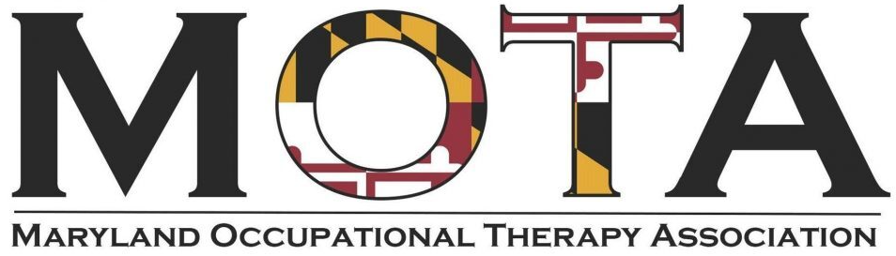
Board openings for Maryland Occupational Therapy Association (MOTA)! Positions are three-year terms and are open to those in good standing with MOTA.
These positions will begin on January 1, 2026.
Secretary
Functions of the Secretary shall:
- Be responsible for the meeting minutes, records, documents, and archives of the Association.
- Secure, archive, and manage the physical and virtual places of storage for MOTA records and documents.
- Attend all Board meetings or appoint a designee.
- Oversee the filings of official documents.
- Have the authority to sign an organizational declaration affidavit.
- Maintain and update the MOTA policy on document retention at least every three years.
- Maintain a calendar of Board meetings, provide meeting notices, and distribute former Board meeting minutes to participants at least two days in advance.
- Take roll call, record attendance, and document minutes during Board meetings and at the Annual Business Meeting or appoint a designee.
- Work with the President in compiling an annual summary of all actions taken by the Board.
- Maintain and regularly update an official contact list of MOTA Officers and their terms of service, Trustees, and selected business contacts.
- Participate in the maintenance of MOTA reference documents and lists such as purchased and/or retired equipment and the history of the organization: past officers, scholarship awardees, etc.
- Monitor and notify the Board of timelines to update business contracts and official documents with the Association.
- Be the main liaison with institutions holding records or artifacts pertinent to MOTA, such as the American Occupational Therapy Foundation’s Wilma L. West library.
- Update MOTA stationery on request of the Board.
- Arrange for MOTA documents to be notarized if needed.
- Participate in the update of standard operating procedures for this position and the training of a successor to the position.

Vice-President, Nominations & Awards:
Functions of the VP of Nominations & Awards shall:
- Be responsible for, and chair committees on; advertising, soliciting, and gathering data for nominations for MOTA offices, membership awards, and sponsored scholarships.
- Attend all Board meetings or appoint a designee.
- Provide a presentation at the Annual Business Meeting.
- Maintain lists and/or records of previous awardees.
- Procure certificates and awards.
- Coordinate presentation of awards at the annual conference and other events.
- Participate in the update of standard operating procedures for this position and the training of a successor to the position.

If interested, please send an email including the position for which you are applying, a brief bio, and a short statement explaining why you feel you would be a strong candidate for the role by January 9, 2026 to Allysin Bridges-German at abridges@towson.edu. Thank you!

